SSMS with Copilot
Fill the fireform to request a new project and Azure OpenAI resource group.
Once the project and resource group has been created, the requestor will receive the link to the project.
You should navigate to the project and create a deployment before adding Copilot to SSMS. Deployment must be created only once by the requestor.
Create a deployment
- Navigate to Models+endpoints in your project and click ‘Deploy Model’ and select ‘Deploy base model’ option.
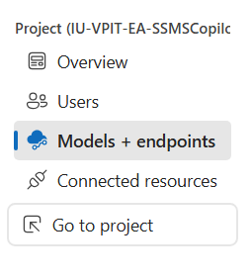
- Select a model. You can choose any model you want.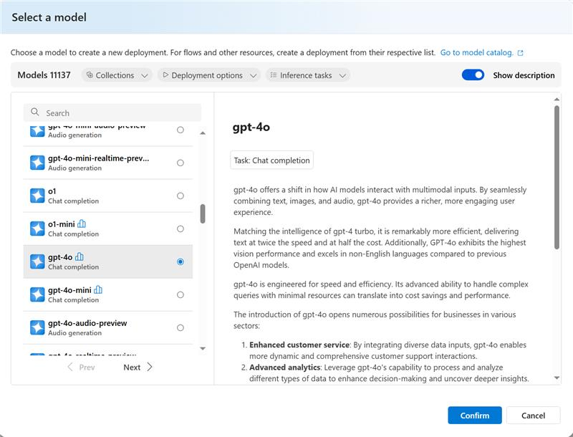
- Enter a unique deployment name. Example: ssms-*team name*-model name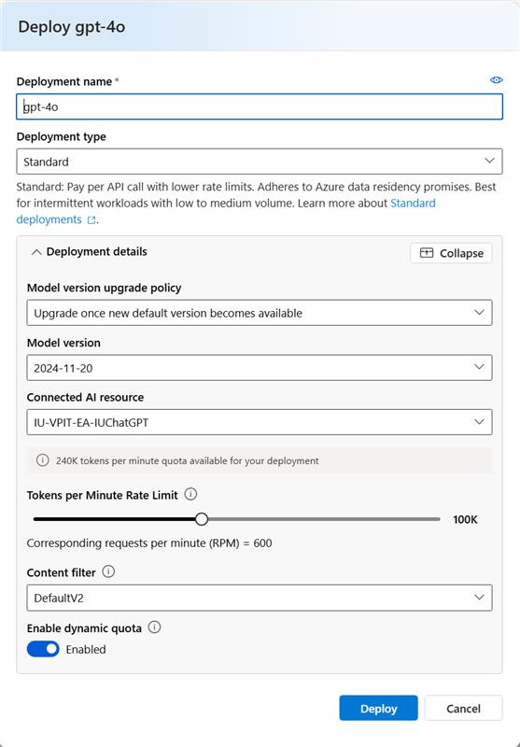

- Once the model has been deployed you can share the end point and deployment with all the users who will be using SSMS with Copilot.
Example:
OpenAI Endpoint URL: https://IU-VPIT-EA-IUChatGPT.openai.azure.com/
OpenAI Deployment name: ssms-gpt-4o

Installing Copilot for SSMS:
Install the latest version of SQL Server Management Studio. To make sure you're running the latest SSMS you can check in Help > About for version number.
If you have the latest version and don't see the Copilot button, then you can launch the installer again and modify the install to add Copilot.
If the permissions were assigned correctly for the Azure OpenAI Resource, then when you click the Copilot button in SSMS for the first time it will prompt you to set it up. If not, go to Tools > Options > Copilot > Azure OpenAI Settings
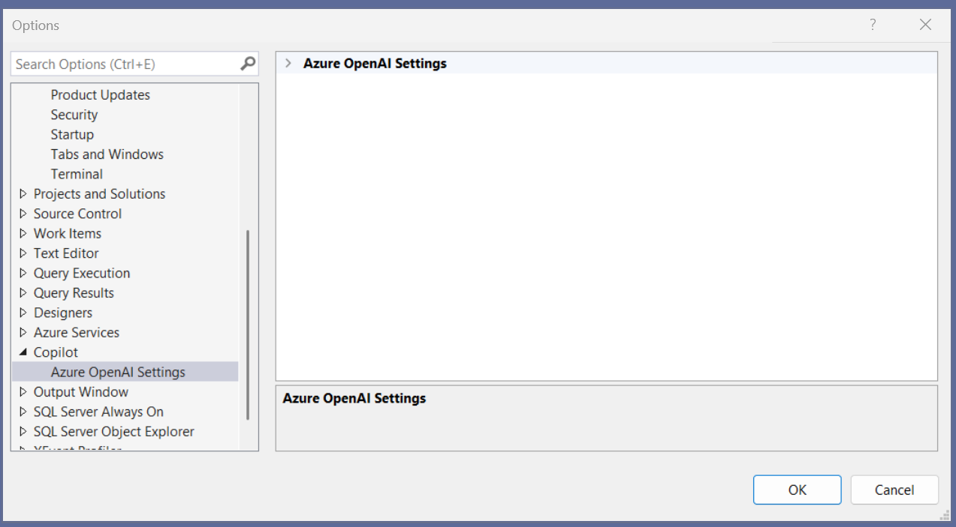
You'll need to know the OpenAI Deployment name and the OpenAI Endpoint URL.
(Leave the API Key field blank, and it will have you login)

Other:
https://learn.microsoft.com/en-us/ssms/copilot/copilot-in-ssms-install

